NAME: KOLA VENKATA CHARAN TEJA
REG NO:192424167
COURSE CODE & NAME: CSA1003 Software Engineering
JIRA LINK: https://aligetiakshaya8.atlassian.net/jira/software/c/projects/FRS/boards/69
EXPERIMENT-1
Create a Kanban Board to Visualize the Tasks.
- Create Columns for To Do, In-Progress and Done.
- Add Atleast 5 Sample Tasks
- Move the Tasks across the Columns to Simulate the Workflow.

Step 1: Login jira
Step 2: Click on spaces which are on the left side of jira with symbol (+) where it creates a new space.
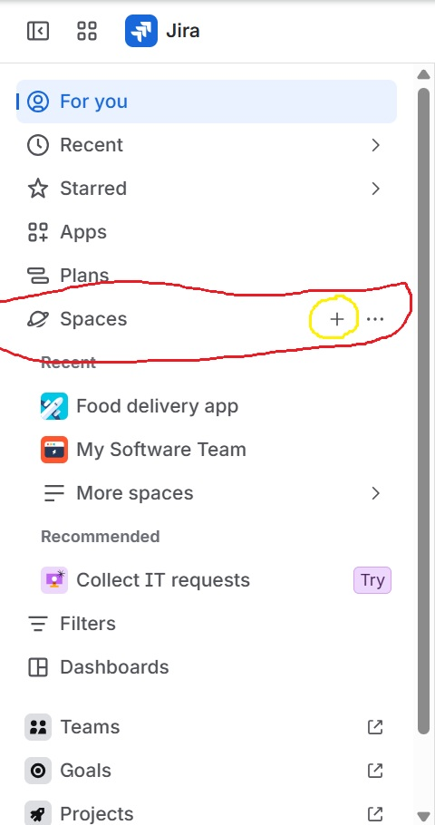

Step 3: We find different options scroll and search for kanban and select kanban.
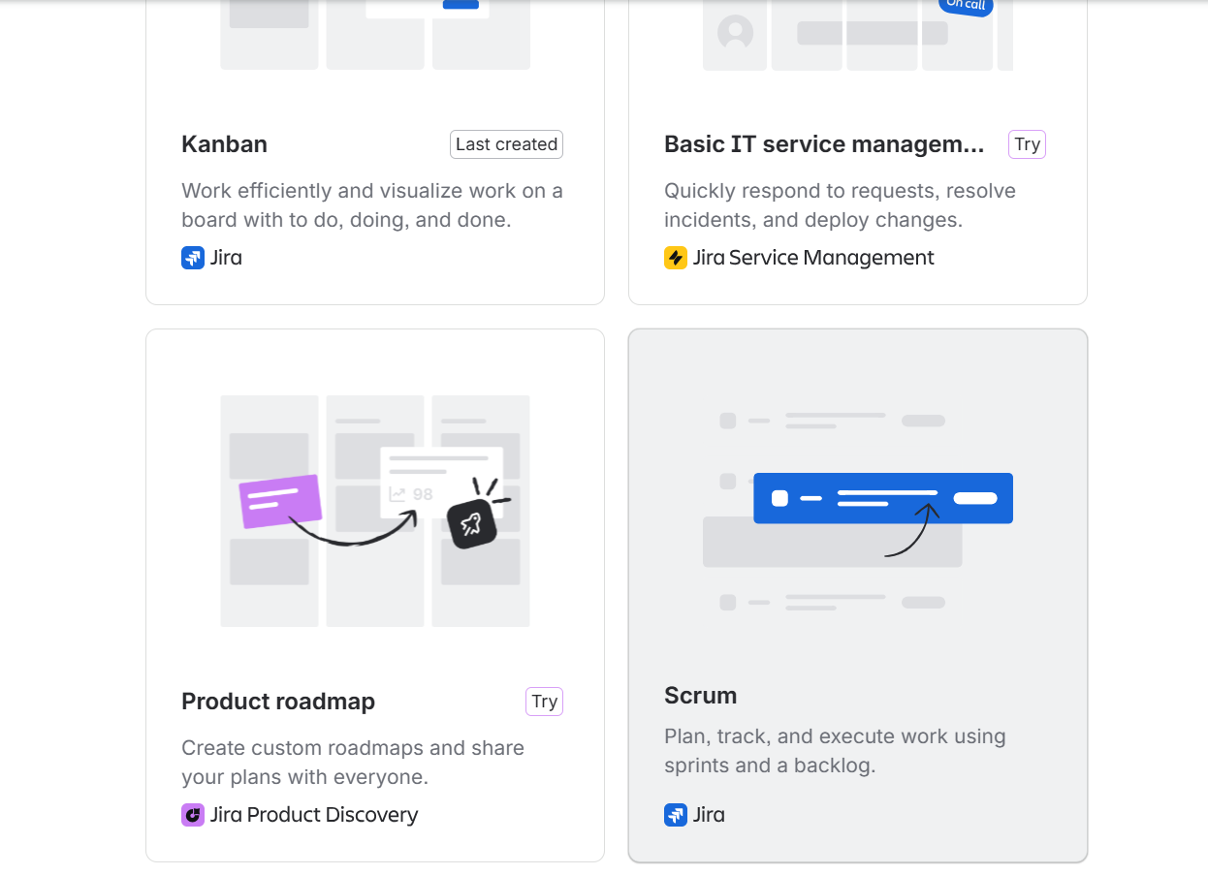
Step 4: Use Template.
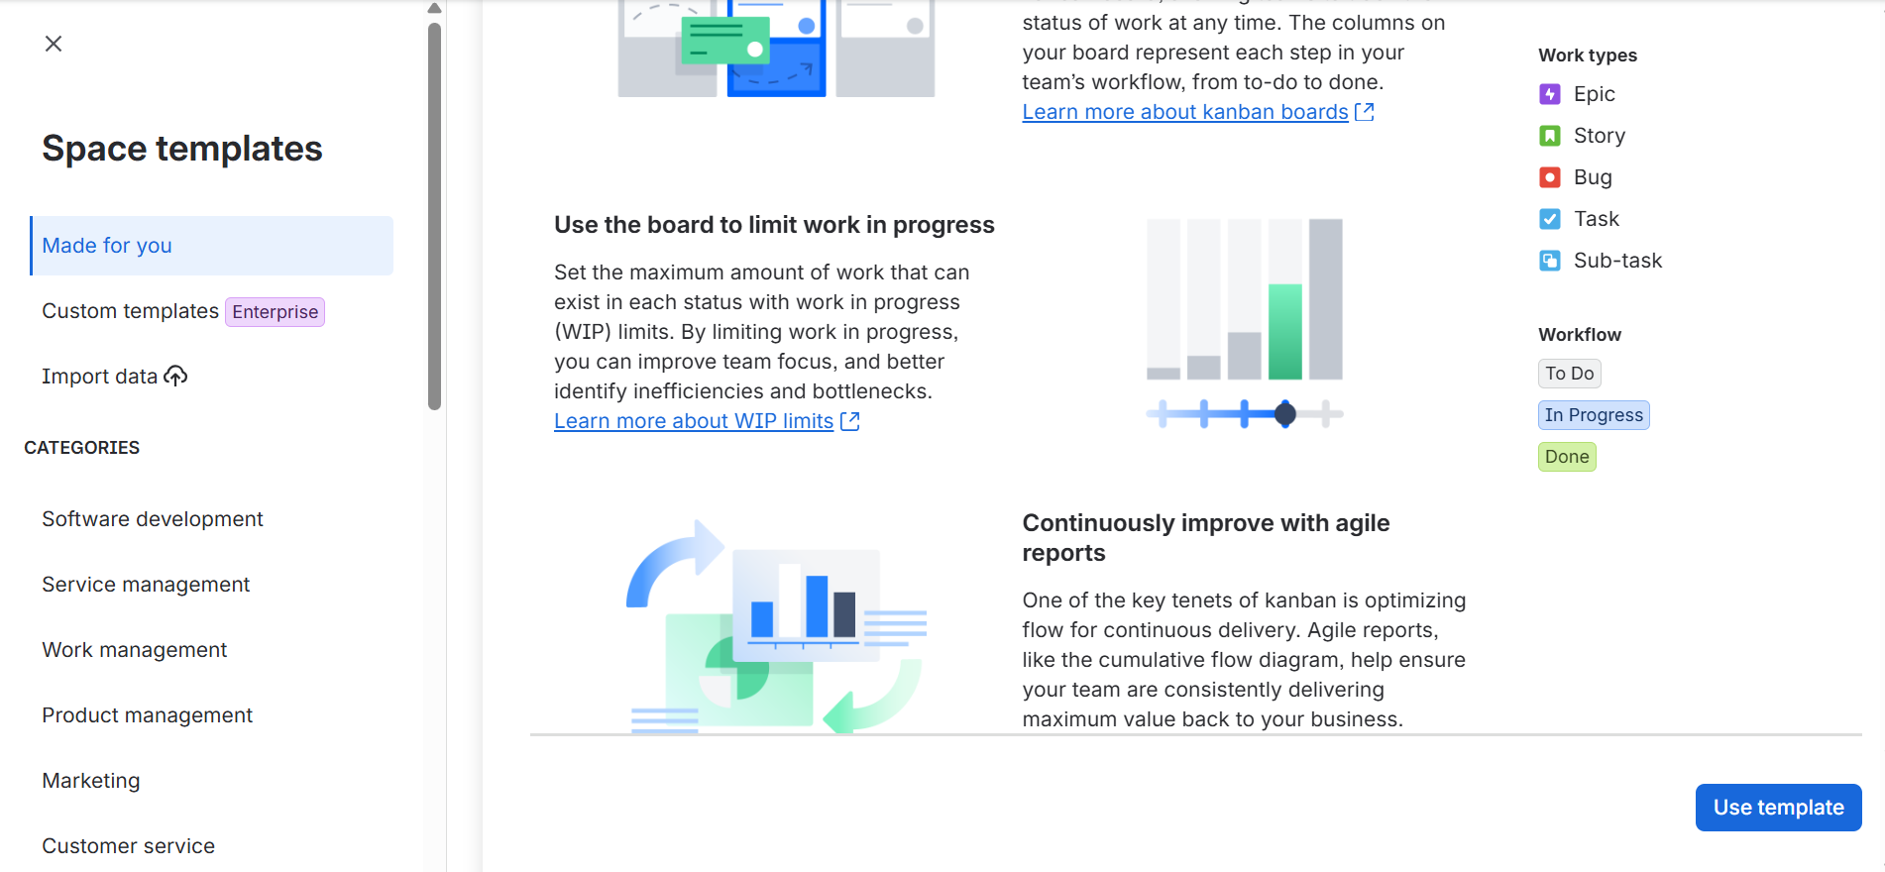
Step 5: Give any name for the space to be created , Select the managed space as company and Click on next.
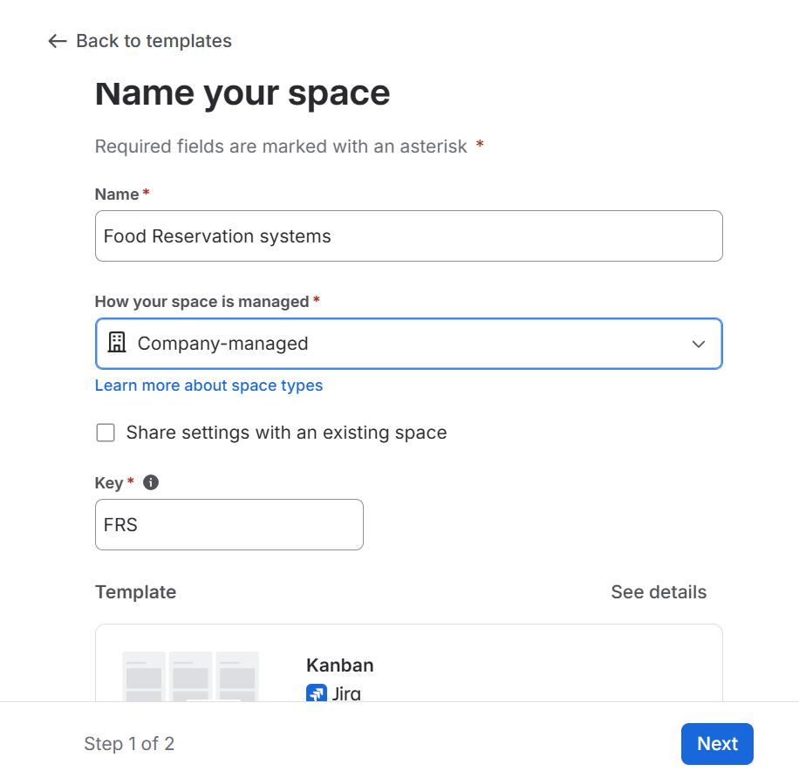
Step 8: Enter the emails of the team to assign them the work.
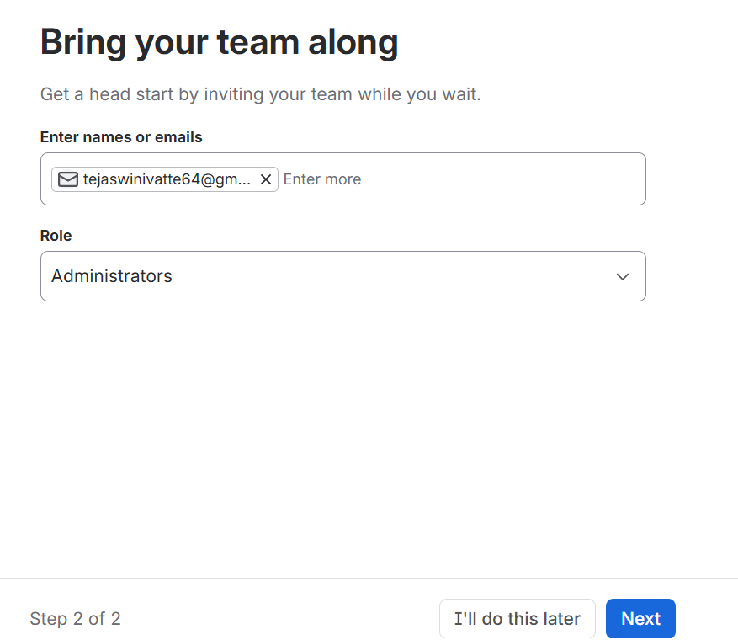
Step 9: Kanban board is created with headings as backlog,selected for development,in progress,done.
Step 10: Now we can add a task and assign it to any of the teammates.
